Screening Survey of the Former Sovereign Oil Site

Introduction.

A screening survey was conducted on October 24, 2016 to assess the level of soil VOCs near the former Sovereign Oil site which is currently occupied by Grand Food Service, LLC. This site is located on the SW corner of American and Berks Streets in the Kensington section of Philadelphia, Pennsylvania. Figure 1 shows a recent aerial view and the insert in upper right hand corner shows the site around 2004.

Figure 1. Survey Site

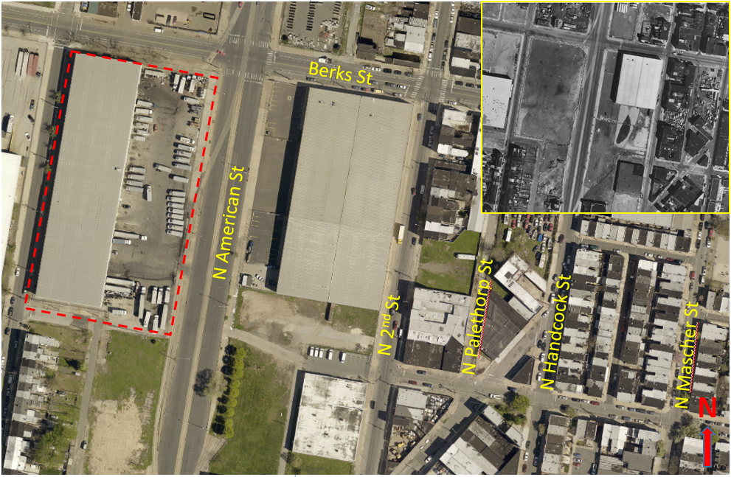

For over 100 years this site has been utilized for industrial activities. An 1887 land use map shows that the Reading Railroad used the property and an adjoining lot east of American Street as a switch yard and a boiler repair shop. A 1942 land use map locates the Radbill Oil warehouse at this site and, more recently, the property was held by Sovereign Oil. In 1992 investigations found significant oil contamination and remediation was completed in 1997. The Pennsylvania Department of Environment reported that 300 cubic yards of soil and 18,000 gallons of “free product” were removed.

Purpose.

The purpose of the study is to is to confirm that the 1997 remediation effectively reduced the VOCs in the soil adjacent to the former Sovereign Oil site. During the twenty-year period since the remediation, it is expected that the process of natural attenuation would bring soil VOCs down to low levels.

Materials and Methods.

The testing procedure utilized an equilibrium headspace analysis. Nine soil samples were collected for the survey and each sample was immediately tested after collection. About 400 ml of soil was collected with a metal scoop and placed in an 800-ml glass jar, sealed with silver foil, covered with a metal lid and vigorously shaken for about 20 seconds. The soil was allowed to equilibrate for 10 minutes after which the sampling tube from a MiniRae 3000 model GP 11012 was pushed through a small hole in metal cover to penetrate the silver foil. The maximum VOC reading obtained in this process was recorded. Prior to soil testing the MiniRae 3000 was successful calibrated with 100 PPM Isobutylene.

Setting.

The survey site lies about 314 meters SE of the fall line for the Delaware River. Underneath a few feet of Urban Fill, the soil type is Trenton Gravel which is described by the USGS as gray or pale-reddish-brown, very gravelly sand interstratified with cross bedded sand and clay-silt beds. The porosity and permeability of Trenton Gravel is very high but this can vary depending by location. Trenton Gravel near the site averages about 30 feet in thickness and the water table within these deposits is high, measuring from -2 to -10 feet in elevation. Basement rock consisting of mica schist lies beneath the Trenton Gravel.

The elevation along Berks St drops about 40 feet moving east from American Street to Handcock Street. On the north and south sides of Berks St the elevation gently rises forming a shallow depression east of the Sovereign Oil site (see Figure 2)

Figure 2. Topography

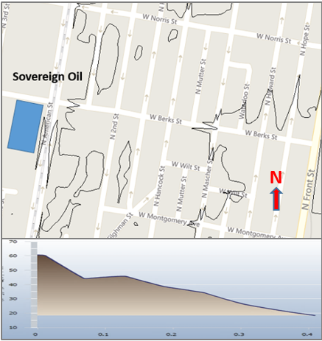

The temperature on Oct 24, 2016 was 63 F, average humidity 42%, rain 0.0 inches and the winds were from the WNW at 9.3 MPH

Results.

The map in Figure 3 presents an elevation of the Sovereign Oil site with the VOC measurements superimposed at their measured latitude and longitude positions. The highest readings, 80.6 PPM and 71.1 PPM, were obtained at the SW corner of the Sovereign oil site with the next higher readings, 57.0 PPM ad 22.3 PPM, obtained east of this point.

Figure 3. VOC Measurements in PPM

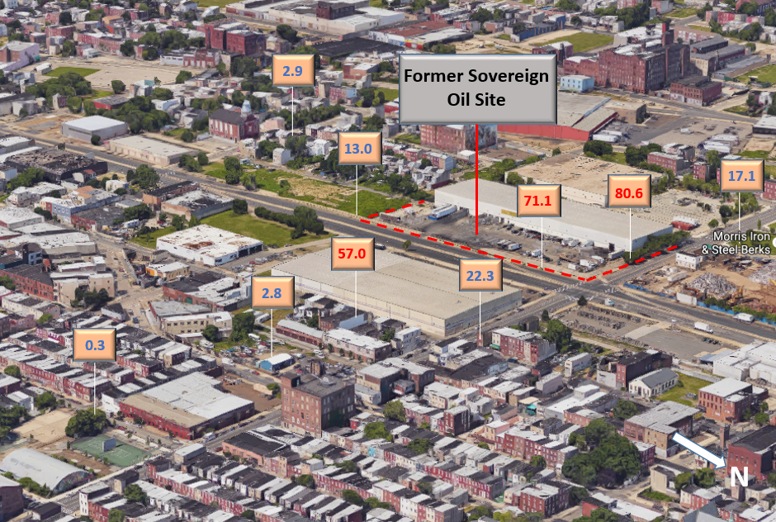

Interpretation.

The data shows that VOCs, are present near the SW corner of the Sovereign Oil Site and, following a shallow depression, have moved some distance east across American St. Although the concentration of VOCs is below what would require remediation in an industrial/commercial zone, these readings would not be suitable for residential property.

The location of the highest VOC level correlates closely with the prior location of several large (about 47,000 gallons) above ground storage tanks (ASTs) situated near the SW corner of Berks St. Figure 4 is a schematic of the above ground storage tanks located outside of the main structure of Sovereign Oil.

Figure 4. Location of Exterior ASTs

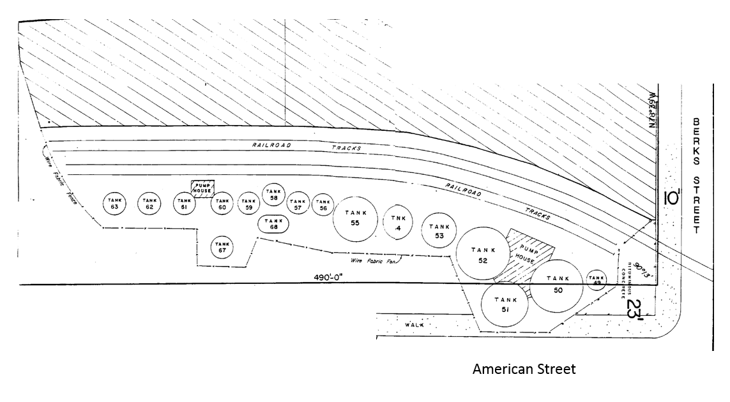

The source of the VOCs cannot be determined through the survey data but several possibilities can be considered. The first is that the VOCs are sourced from residual contamination that is migrating through or around the geofabric and other containment materials installed during the remediation process. The survey data correlates well with this assumption in that the VOCs seem to originate at the SW corner of Berks and follow the downhill grade, east on Berks Street.

The difficulty with this explanation is that we would expect any residual contamination to be depleted through the process of natural attenuation given that the site was remediated almost 20 years ago. Soil bacterial and other physical processes can effectively break down many petroleum products over time even under anaerobic conditions. Special circumstance would be required to explain the preservation of hydrocarbons at this site.

Another explanation is that the high VOC levels reflect a small spill of paint, solvent or other organic compound that occurred well after the remediation. It is not uncommon to find local hotspots but VOCs levels all stand in a spatial relationship with each other which argues against a random hotspot. The VOC levels furthest from Sovereign Oil are lowest and the ones on the downhill side of the site are higher than those on uphill side.